**Part1: Create a github account**

1. Go to github.com
2. Incase you have existing github account please use or sign up for a new account
3. If you choose to sign up for a new account, click ‘Sign up’ at the top right
   1. Create a username. You might need to use a personal email address
   2. You will need to check your email and verify that your email address is real

**Part2: creating repo on github**

Create a private repository in your GitHub account called “gittraining”  
a. Name: repo-lab  
b. Choose ‘Public’  
c. Do not initialize with a README  
d. Click the green ‘Create Repository’ button

[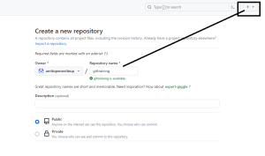](https://usercontent.one/wp/www.openwriteup.com/wp-content/uploads/2023/08/git.png?media=1728024675)

Copy the SSH URL under ‘Quick Setup’

[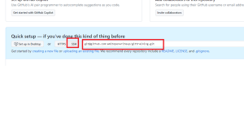](https://usercontent.one/wp/www.openwriteup.com/wp-content/uploads/2023/08/git2-1.png?media=1728024675)